**Linux Environment Variable Assignment**

1. State the command for the following.
   1. 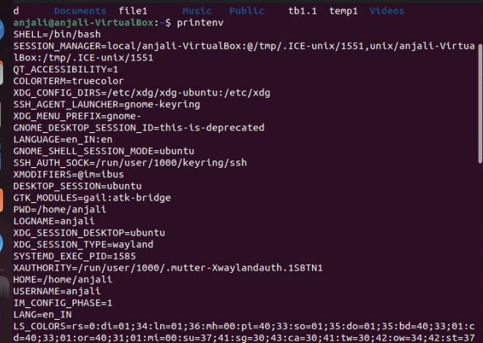view current environment variables
   2. display the PATH evirnment variable value

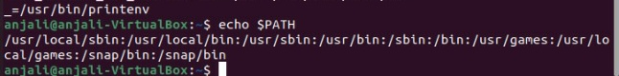

* 1. update PATH to include the path to your home directory

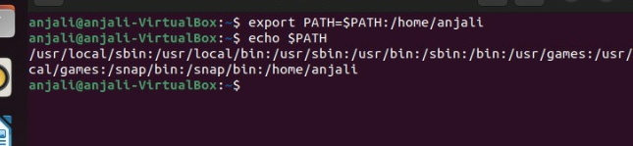

1. How will you make the environment changes applicable to all users? Which script is to be modified?

* To make permanent changes to the environment variables for all new accounts, go to your /etc/skel files, such as .bashrc, and change the ones that are already there or enter the new ones. When you create new users, these /etc/skel files will be copied to the new user's home directory

1. I have installed an application named “myapp”. After installation, if I invoke the application, it fails with error as “Command myapp not found”. How will you fix this?

* Use ‘npx’ to solve the error.